Title
Authors and affiliations
Abstract text
Abstract proposal length: Max 300 words (main text)
Language: English
Mention the conference track: 1) Dual Higher Education, 2) Healthy Living, 3) Future of Work or 4) Green Economy
Structure:
- Background / Context: Briefly introduce the problem or topic, and explain why it matters or what gap it addresses.
- Objective / Purpose: State the aim of your research or project (what question are you trying to answer?)
- Methods / Approach / Case: Describe how the study was conducted or explain the case. Include techniques, data sources, or frameworks used.
- Results / Findings: Summarize key outcomes or discoveries.
- Conclusion / Implications: What do the results mean? Practical implications? Highlight the significance, impact, or future directions.
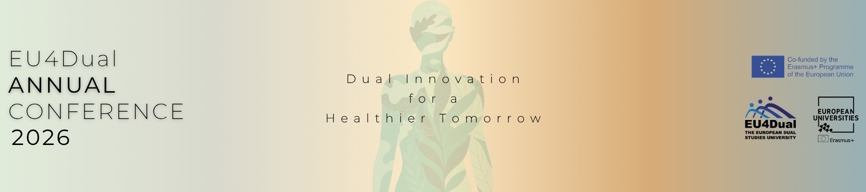
Key Words: max 5 keywords

